**About SapUI5**

What is spaui5?

SAPUI5 is the new framework of UI development based on HTML5 technology developed by SAP to build the mobile and desktop application.

What new in sapui5?

It is responsive. Follows the policy - build once and run anywhere.

New rich set of data binding API's.

Strictly follows the MVC architecture.

Rich set of Maps, Charts available.

Sapui5 vs openui5?

SAPUI5 and OpenUI5 both are same technology except these two different given below.

1. SAPUI5 is license version. OpenUI5-open source.

2. OpenUI5 not all the controls and libraries available here which is available in SAPUI5.

Versions in sapui5

Version 1.34.

Version 1.32.

Version 1.30.

Version 1.28.

Version 1.26.

What does replace it?

It can replace previous technology such as web-dynpro and BSP.

Sapui5 Bootstrap

What is bootstrap?

SAPUI5 is JavaScript framework. It contains so many libraries. Initializing and loading all these libraries into the application is called Bootstrapping.

In Details:-

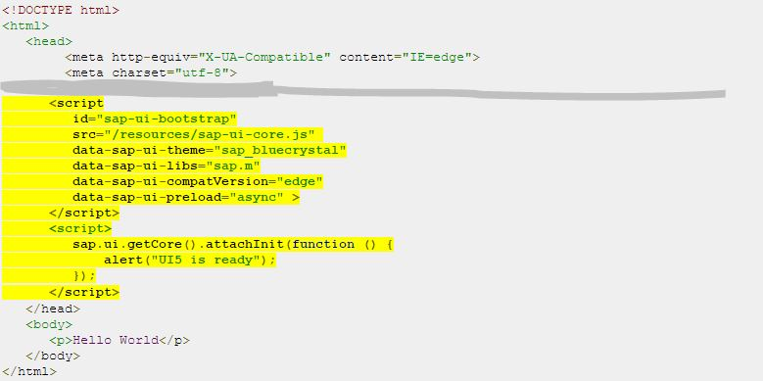

sap-ui-core.js ---> This is standard and main file of bootstrap. This file hits the boot code which loads all other libraries. This file also contains jquery plugin in it.

data-sap-ui-theme ---> SAPUI5 has different themes in it. This option is to select theme. sap_bluecrystal is one of the the theme.

data-sap-ui-libs ---> The libraries which is mention in this section will load at the time of bootstraping.

data-sap-ui-compatVersion ---> SAPUI5 change version is given here which is compatible. 'edge' for latest compatible version.

data-sap-ui-preload ---> Option to load the libraries in sync or async mode.

Sapui5 Controls:-

What is sapui5 controls?

Controls are used to define baheviour and appearance of display. Like in simple html5 we are using tags to make screens and appearance here we have controls for that. e.g. table controls , image control, button control etc.

What is the advantage using controls over tags?

SAPUI5 has defined different controls for different screen sizes. e.g. sap.m library contains the mobile controls , sap.ui.commons library contains desktop and common controls.

For every controls all the common events, properties, bahaviour associated to them has already defined. e.g. for table control behaviour like sorting, grouping, filtering are pre-defined in sapui5.

New controls can be made easily by extending sap.ui.core control.

Some new controls which are more useful in business scenario are pre-defined in SAPUI5. e.g. business card.

For graph, layout, maps separate controls has been given in SAPUI5.

View

What is the view?

View are the file related to display of application. In SAPUI5 we have four types of views. All the controls explained above has to be define in the view.

Types of view?

XML View

Advantage : favours strict separation between view and logic. Can be build with layout editor. Using namespace makes the code small.

Javascript view

Advantage : Pages can be dynamic. Function can be written in the view file. Debugging of view is possible. Object oriented code can be written in this.

HTML view

Not preferred view for development.

Json view

Not preferred view for development.

Sapui5 Controller:-

What is controller?

Controller are the file responsible for handling the user input and responses. It separate the view logic from model logic.

In Details

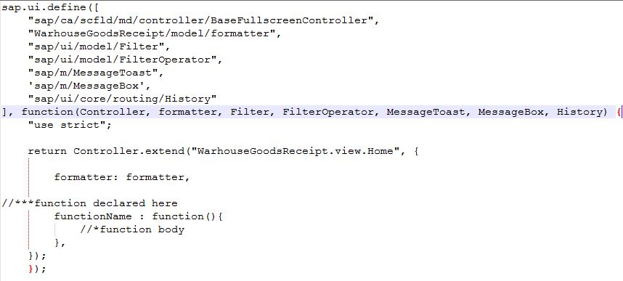

sap-ui-define ---> Defines a javascript module.

sap-ui-model-filter ---> Filter controls library or path which has given namespace as Filter. same with others.

use-strict ---> Tells browser to execute the code in strict mode. Helps in detecting the issue in early development stage.

SapUi5 Model

What is model?

Model is that part of application which holds the application data. It retrieve the data from database and store the data. SAPUI5 has four types of model.

JSON Model

Feature: 1.Support JavaScript object data 2.It is client side model 3.Support two way binding 4.Support small data that is available on client side

XML Model

Feature: 1.Support xml data 2.It is client side model 3.Support two way binding 4.Support small data that is available on client side

Resource Model

Feature: 1.Use to handle the application resource 2.It has method to add and remove resource

OData Model

Feature: 1.Supports OData 2.It is a server side model 3.Suitable for large amount of data available on server

SapUi5 Component:-

What is Component?

Component is the file which encapsulated UI asset of the application. We can also bind our UI asset in index.html file but since index.html is a static file it has some disadvantage. While component.js is a JavaScript file it has some advantage over index.html. Component makes our application more flexible and allow architecture changes dynamically.

In Details

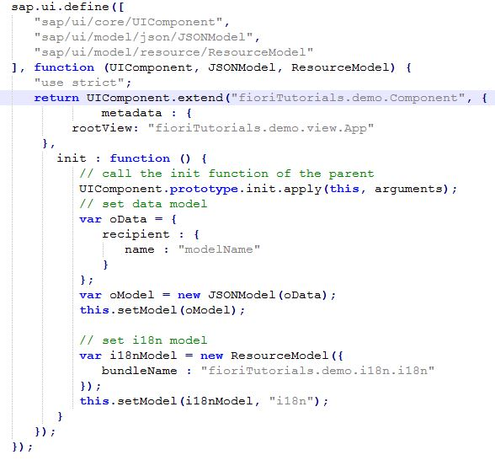

metadata section ---> Here we have simply defined the root view.

init section ---> Here we have defined the models.

# SAPUI5 Descriptor

#### [**What is Descriptor?**](http://www.fioritutorials.com/sapui5-theory/sapui5-descriptor.html#collapseOne)

Component has all the UI asset information but what about additional resource required by application such as device setting, supported language , platform etc. These are called application specific setting. For all these information SAPUI5 has separate file called manifest.json. It is called application descriptor. Using this file all the local setting for specific application can be managed.

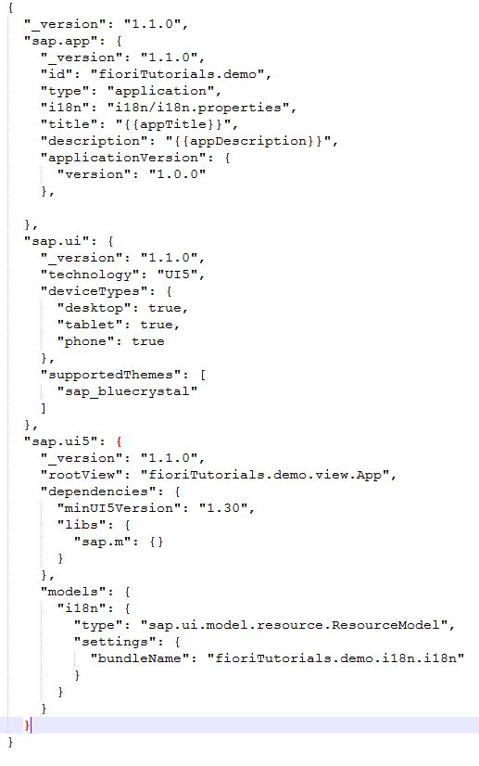

#### [**manifest.js file in Details**](http://www.fioritutorials.com/sapui5-theory/sapui5-descriptor.html#collapseTwo)

"sap.app" contains following attributes

id : Namespace of the application component.Also mandatory field.

type : Defines what are we configuring. e.g. here an application.

i18n : Path to the resource bundle file.

title : Title of the application.

description : Application description

applicationVersion : Application version. Makes it easy to update or modify.

"sap.ui" contains following attributes

technology : Specifies the UI technology.

deviceTypes : Application supported device. here desktop, tablet, phone.

supportedThemes : Themes supported by the application. here sap_bluecrystal.

"sap.ui5" contains following attributes

rootView : Specify the component and initiate it.

dependencies: All UI libraries used in the application.

models : Defines models that initiates automatically when application loads.

#### [**Component.js after adding manifest**](http://www.fioritutorials.com/sapui5-theory/sapui5-descriptor.html#collapseThree)

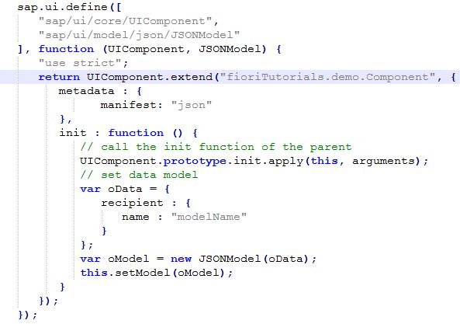

After adding manifest.js there is no need to declare rootView here. Also no need to declare resource bundle file i18n.

# SAPUI5 Custom CSS

#### [**Why need custom css?**](http://www.fioritutorials.com/sapui5-theory/sapui5-custom-css.html#collapseOne)

Although all the controls of SAPUI5 has its own css style and size but if you want to override the existing style then you need to use custom css. But I will suggest not to use custom style until it is necessary.

#### [**CustomStyle.css how it looks**](http://www.fioritutorials.com/sapui5-theory/sapui5-custom-css.html#collapseTwo)

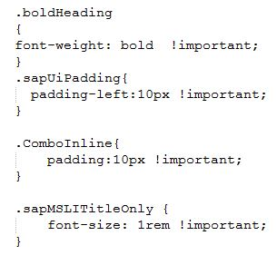

#### [**Adding to manifest.js**](http://www.fioritutorials.com/sapui5-theory/sapui5-custom-css.html#collapseThree)

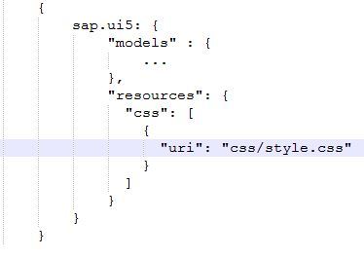

# SAPUI5 Fragment

#### [**What is Fragment?**](http://www.fioritutorials.com/sapui5-theory/sapui5-fragment.html#collapseOne)

Fragment is light Ui part defined similiar to view except it does not have controller associate to it.

#### [**Advantage and feature of fragment**](http://www.fioritutorials.com/sapui5-theory/sapui5-fragment.html#collapseTwo)

Can be access by all views because it is defined in separate file.

No need to declare controller.

Whenever there is a requirement of making UI part which does not have controller logic associated to it that time fragment can be used.

One or more controls can be defined here.

#### [**How to declare**](http://www.fioritutorials.com/sapui5-theory/sapui5-fragment.html#collapseThree)

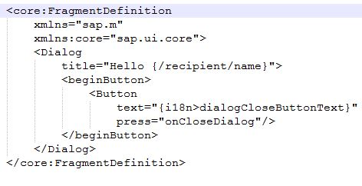

#### [**Types of fragment**](http://www.fioritutorials.com/sapui5-theory/sapui5-fragment.html#collapseFour)

XML fragment

Similar to XML view except no view tag define fragment definition and inside it define controls.

HTML fragment

Not preferred fragment type.

JS fragment

Not preferred fragment type.

# SAPUI5 Icons

#### [**Icons in SAPUI5**](http://www.fioritutorials.com/sapui5-theory/sapui5-icon.html#collapseOne)

SAPUI5 has more than 500 icons. Icons can be used in the controls whichever has icon properties. e.g.Button

#### [**How to use icon?**](http://www.fioritutorials.com/sapui5-theory/sapui5-icon.html#collapseThree)

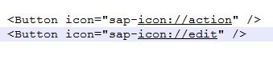

sap-icon ---> Indicates sapui5 icons

edit ---> Icon name

# SAPUI5 OData

#### [**What is OData?**](http://www.fioritutorials.com/sapui5-theory/sapui5-odata.html#collapseOne)

OData is a HTTP and REST based protocol which allow to create, update, delete, read operation with data and resource in standard way.

#### [**In Details**](http://www.fioritutorials.com/sapui5-theory/sapui5-odata.html#collapseThree)

In SAPUI5 we create service to fetch the data from backend and to update backend data.

These service contains the data either in XML format or in JSON format.

SAPUI5 already have methods to consume these odata service. Basically four methods are available.

1.Read 2.Post 3.Update 4.Delete ---> How to implements these operations that we will see in practical section.

# SAPUI5 Filtering

#### [**What is Filtering?**](http://www.fioritutorials.com/sapui5-theory/sapui5-filtering.html#collapseOne)

Filtering is the searching on available items. Based on filter value it will shows the available items. It can be apply to the controls which supports filtering. e.g. Table,List

#### [**In Details**](http://www.fioritutorials.com/sapui5-theory/sapui5-filtering.html#collapseThree)

View

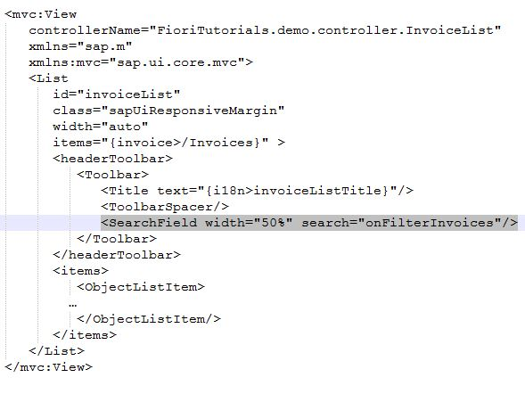

Controller

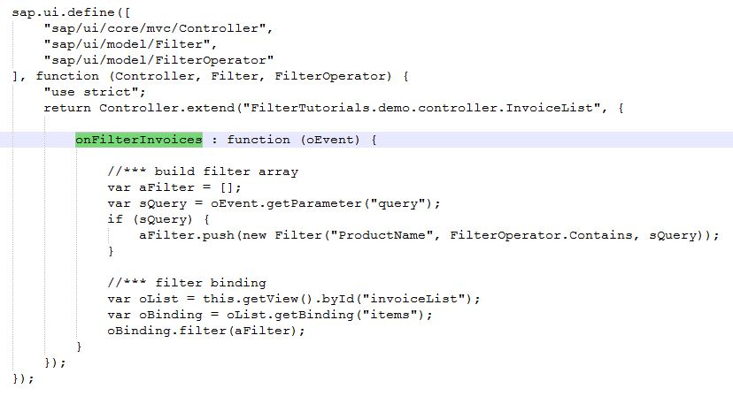

SearchField ---> In View search field is a control which has search property. By triggering search event we are calling 'onFilterInvoices' function. which is defined in controller.

onFilterInvoices ---> In Controller we have defined this function. Now in this function the first thing that we will do to get the search value and store it to some variable , here the variable name is sQuery. Now we will create filter Object which holds the search value, model field path on which filter is happening,and filter operator. After that we will push all these object into an array. Now we will get the all the available items. Here oBinding contains all the items. Now we will pass this filter array to this items and it will to the filter.

Filter object ---> New sap.ui.model.Filter(vFilterInfo, vOperator?, oValue1?, oValue2?)   
vFilterInfo = Filter path or the field name on which filter is applying   
vOperator = Filter operator. e.g.equal, contains,greater that,less than   
oValue1 = Value of the search field   
oValue2 = Value of the search field - Optional

# SAPUI5 Sorting

#### [**What is Sorting?**](http://www.fioritutorials.com/sapui5-theory/sapui5-sorting.html#collapseOne)

Showing the items in alphabetically is called sorting. It is more user friendly.

#### [**In Details**](http://www.fioritutorials.com/sapui5-theory/sapui5-sorting.html#collapseThree)

View

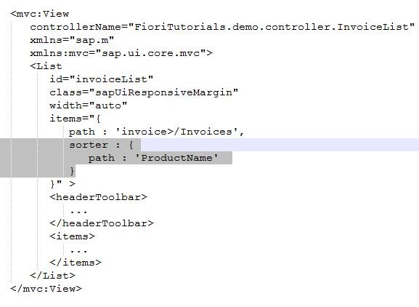

Sorting can be applied on table or List controls which contains more than one items.

sorter ---> Sorting property name

path ---> Path is the path of the field on which sorting is applying. Here its 'ProductName'.

# SAPUI5 Grouping

#### [**What is Grouping?**](http://www.fioritutorials.com/sapui5-theory/sapui5-grouping.html#collapseOne)

Showing the same characteristic items in particular group. In SAPUI5 grouping can be applied with sorting.

#### [**In Details**](http://www.fioritutorials.com/sapui5-theory/sapui5-grouping.html#collapseThree)

View

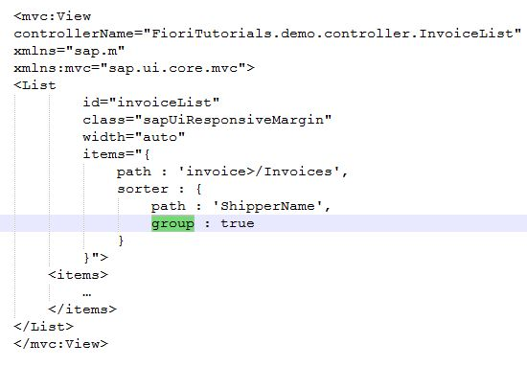

group ---> Grouping property name.

Here items will be group based on 'ShipperName'. Means whichever items have same 'ShipperName' value it will show in same group.

SAPUI5 also supports custom grouping fuction. How to apply custom grouping that we will see in FioriTutorials.com practical section.

# SAPUI5 Navigation

#### [**What is Navigation?**](http://www.fioritutorials.com/sapui5-theory/sapui5-navigation.html#collapseOne)

First we need to understand the concept of navigation. There are two types of application 1.Single Page Application 2.Multipage application. In Multipage application for if you want to navigate you just have to pass the name of page where you want to navigate. But in Single page application it is bit tricky. SAPUI5 standart application are single page application. This single page contains multiple views. So if you want to navigate to other view you need to pass view's name in navigation container.

#### [**In Details**](http://www.fioritutorials.com/sapui5-theory/sapui5-navigation.html#collapseThree)

View

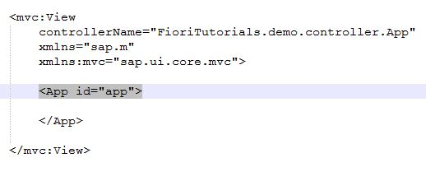

Controller

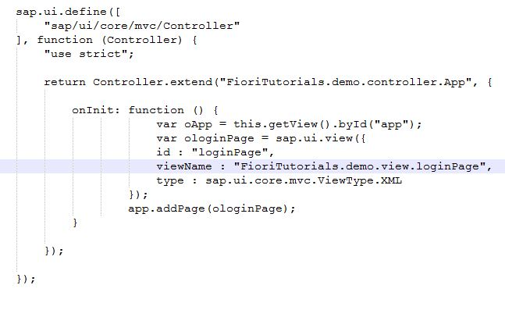

App ---> SAPUI5's root control. App has predefined methods to add and navigate pages. Other root controls are splitApp,navContainer etc.

oApp ---> It is the App container that we have defined above in the view.

ologinPage ---> It is the another view that is defined seperately. This view we will add now in the app container.

app.addPage(loginPage) ---> Adding loginPage view to app controls